**Requirements:**

Requirement 1:

Name: Homepage

User Story: As a player, I want to have a homepage so that I can create a new game, look at high scores, and edit sound settings

Priority: 1

Time to complete: 2 Days

Completion date: October 17th

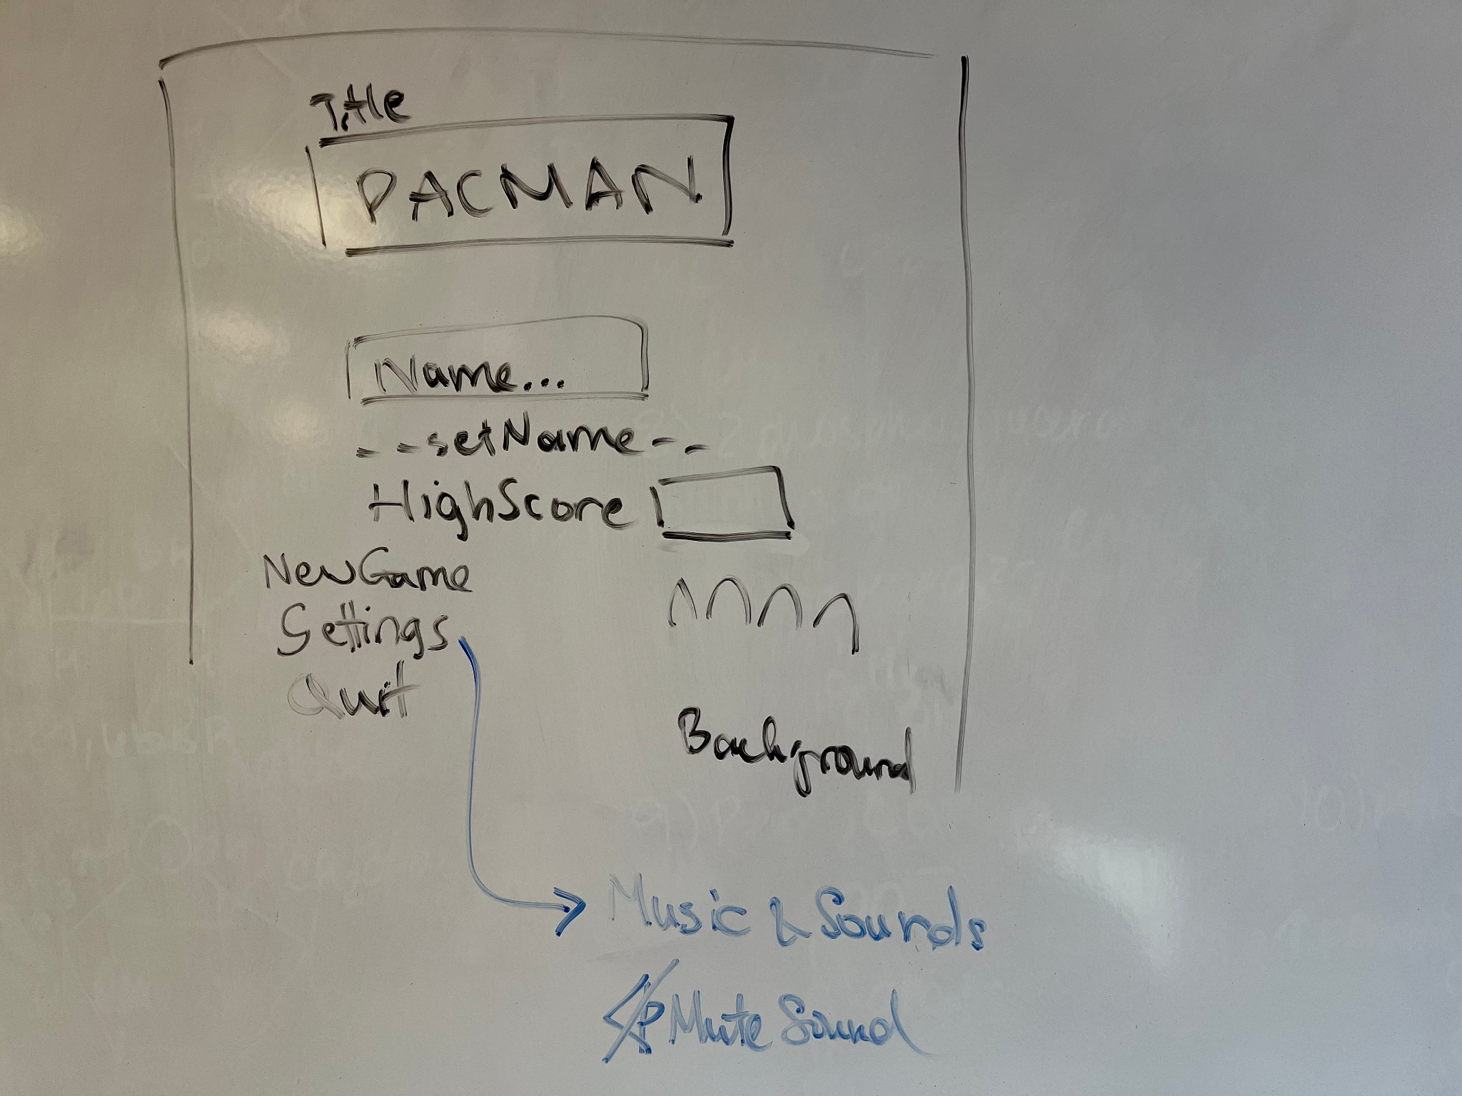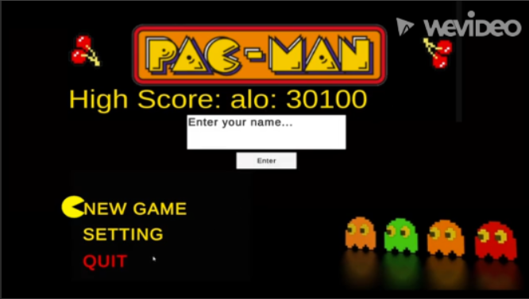

Requirement 2:

Name: Sprites

User Story: As a player, I want to have sprites so that I can experience a visually stimulating game with unique characters, enemies, and powerups

Priority: 2

Time to complete: 5 Days

Completion date: October 22nd

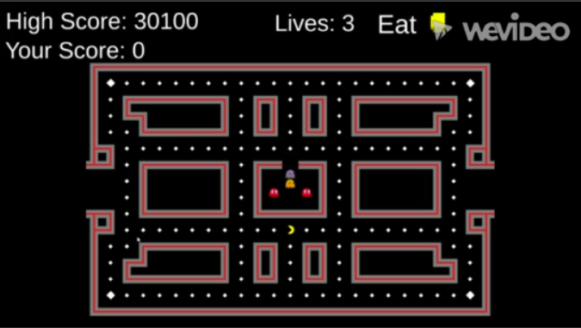

Requirement 3:

Name: Environment

User Story: As a player, I want to have an environment so that I can play the game on multiple maps

Priority: 3

Time to complete: 2 Days

Completion date: October 24th

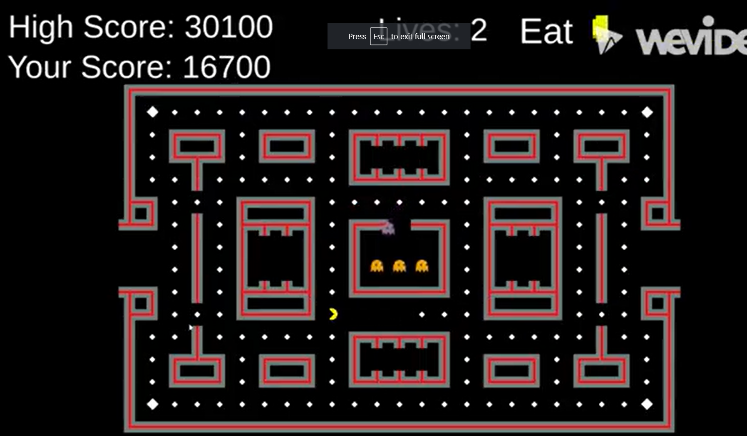

Requirement 4:

Name: Character

User Story: As a player, I want to have a controllable character capable of moving, eating enemies, and scoring points.

Priority: 4

Time to complete: 2 Days

Completion date: October 26th



Requirement 5:

Name: Enemies

User Story: As a player, I want to have enemies to defeat so that I can gain points and have a challenging experience

Priority: 5

Time to complete: 2 Days

Completion date: October 28th

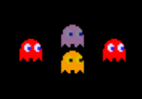

Requirement 6:

Name: Scoring

User Story: As a player, I want to be able to see my score so that I know how well I am doing and how i compare to the competition

Priority: 6

Time to complete: 6 Days

Completion date: November 3rd



Requirement 7:

Name: Powerups

User Story: As a player, I want to be able to collect power-ups that allow me to eat enemies faster, move faster, double my points, give me invisibility, or give me an extra life.

Priority: 7

Time to complete: 3 Days

Completion date: November 6th

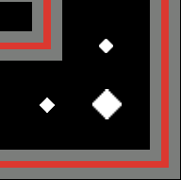

Requirement 8:

Name: Pause Menu

User Story: As a player I want to be able to pause my game so that I have control over when I play or stop

Priority: 8

Time to complete: 1 Day

Completion date: November 7th

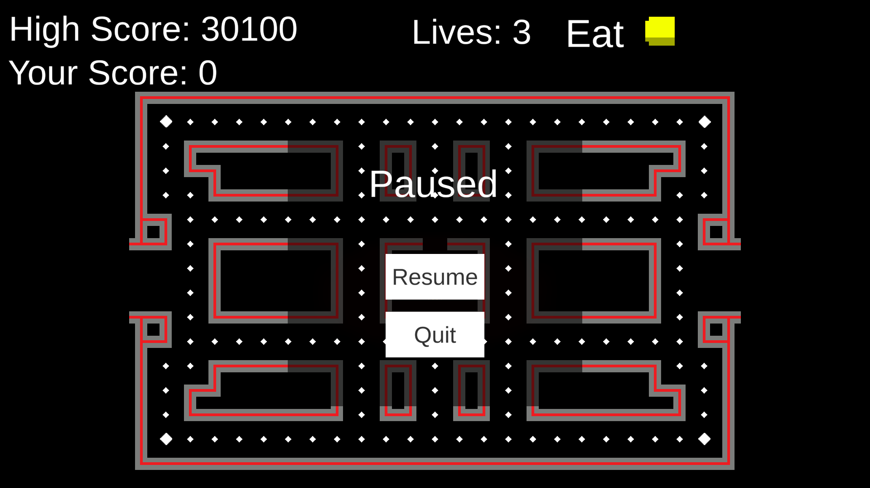

**Architecture Design:**

* **Unity and UnityHub:** Utilized as the main development platform for our pacman game. This includes the integration of game assets, creation of levels, and the design of UI aspects.
* **Visual Studio Code:** Utilized as the main IDE for the coding of C# scripts for our game. Works in conjunction with Unity to allow for easy creation, access, and editing of necessary game scripts.
* **PlasticSCM:** The main collaboration tool used within unity. Allows users to upload changes similar to Github, but contained completely within Unity, making it more convenient.

**Interaction Design:**

